Test Case: tc002_SPX_Dev5_Crear_Requisicion_Spot_Con_FAD_Tipo_Cobro_CC
Step 1 - Enter username and password and click to button Enter : Credentials Entered
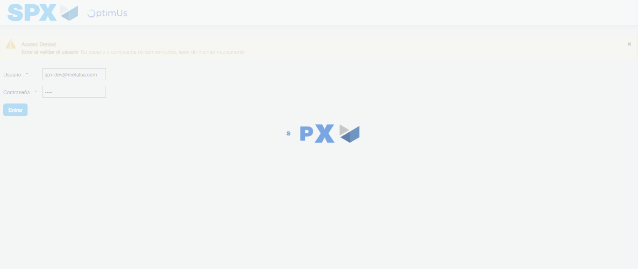Image file-name: QC_Testing-tc002_SPX_Dev5_Crear_Requisicion_Spot_Con_FAD_Tipo_Cobro_CC-1783355443425

Step 2 - Select to UEN and Access to Spot Buy Requisitions : UEN Correctly selected and Correct access
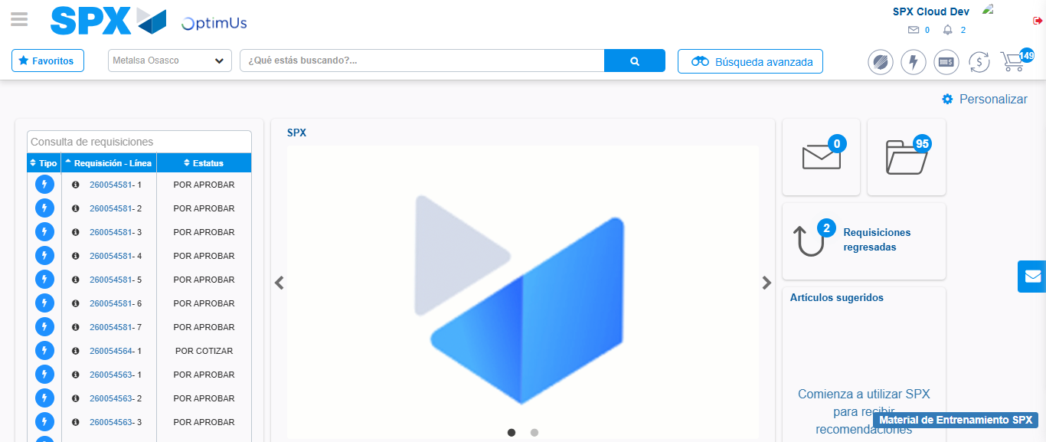Image file-name: QC_Testing-tc002_SPX_Dev5_Crear_Requisicion_Spot_Con_FAD_Tipo_Cobro_CC-1783355469377

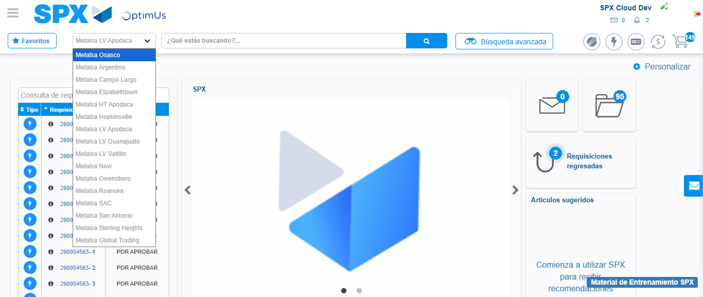Image file-name: QC_Testing-tc002_SPX_Dev5_Crear_Requisicion_Spot_Con_FAD_Tipo_Cobro_CC-1783355472077

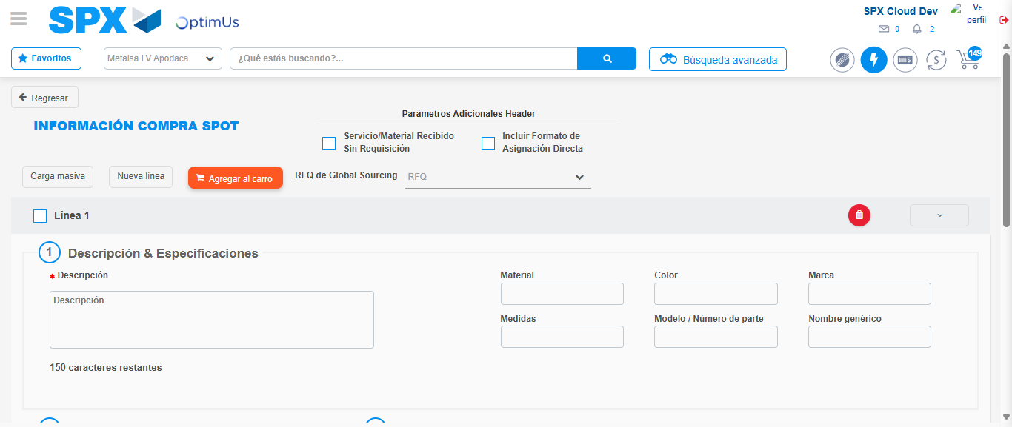Image file-name: QC_Testing-tc002_SPX_Dev5_Crear_Requisicion_Spot_Con_FAD_Tipo_Cobro_CC-1783355497351

Step 3 - Add FAD to Requisition: FAD Successfully Added
Image file-name: QC_Testing-tc002_SPX_Dev5_Crear_Requisicion_Spot_Con_FAD_Tipo_Cobro_CC-1783355497644

Image file-name: QC_Testing-tc002_SPX_Dev5_Crear_Requisicion_Spot_Con_FAD_Tipo_Cobro_CC-1783355497859

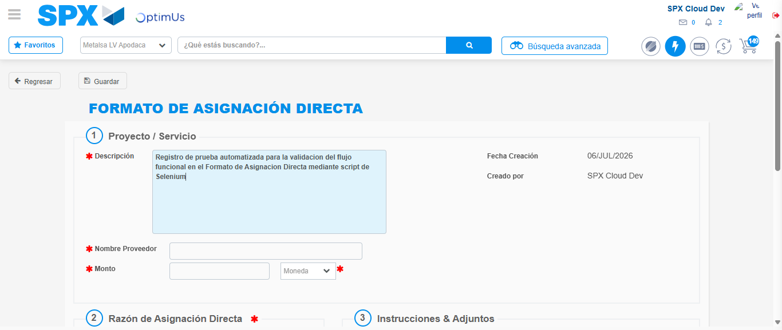Image file-name: QC_Testing-tc002_SPX_Dev5_Crear_Requisicion_Spot_Con_FAD_Tipo_Cobro_CC-1783355500969

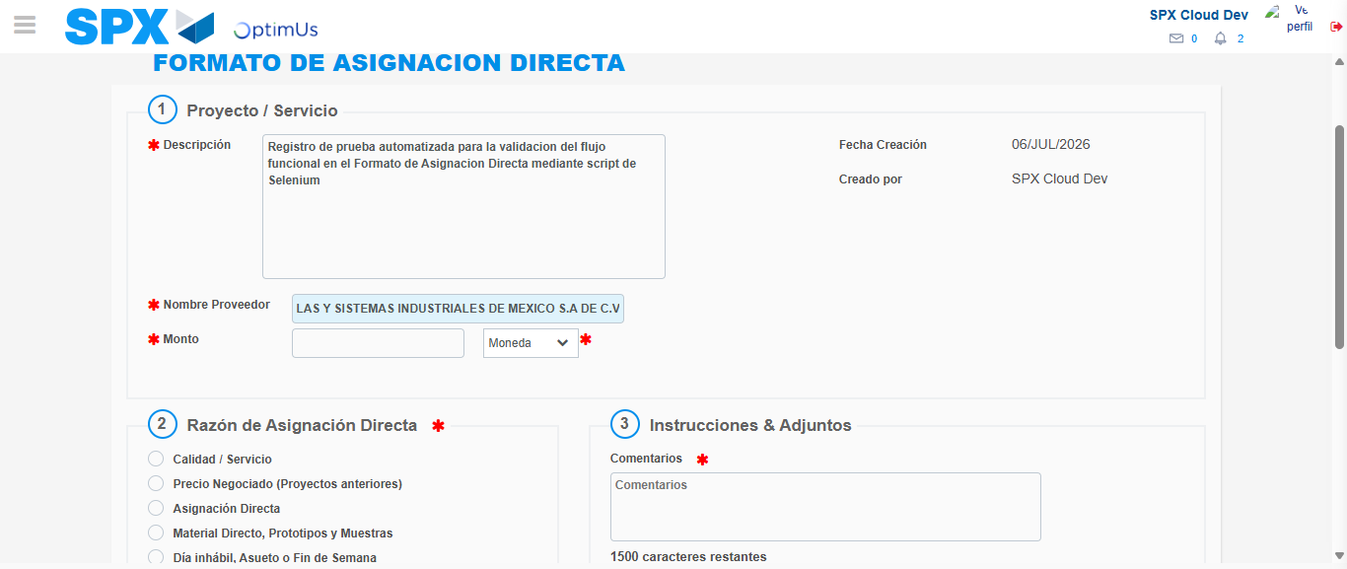Image file-name: QC_Testing-tc002_SPX_Dev5_Crear_Requisicion_Spot_Con_FAD_Tipo_Cobro_CC-1783355509384

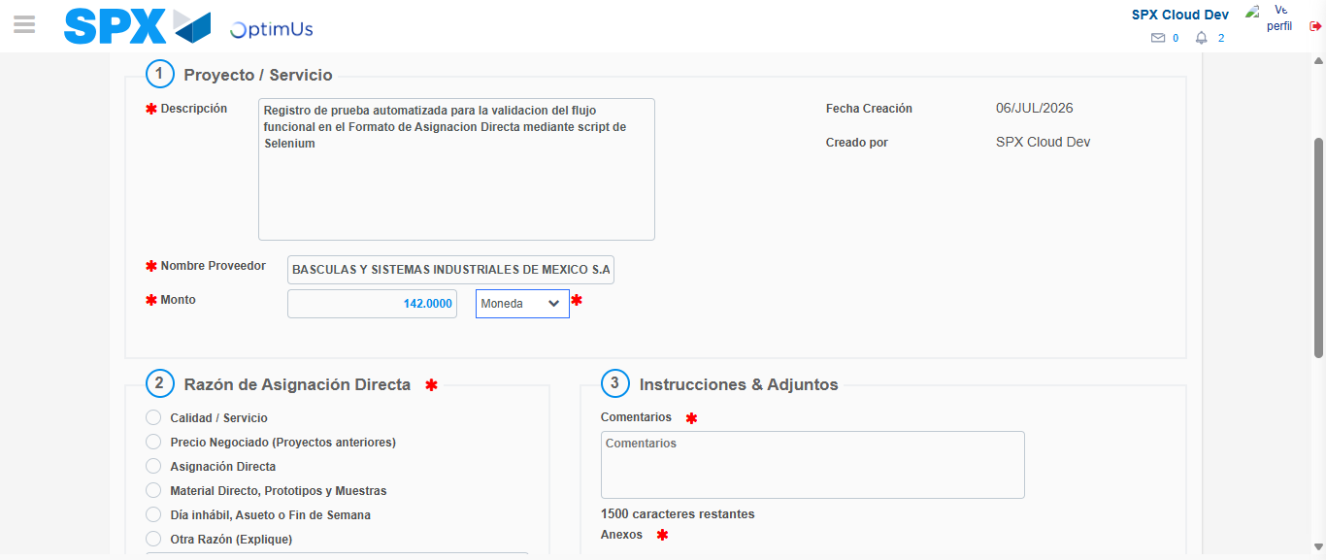Image file-name: QC_Testing-tc002_SPX_Dev5_Crear_Requisicion_Spot_Con_FAD_Tipo_Cobro_CC-1783355509863

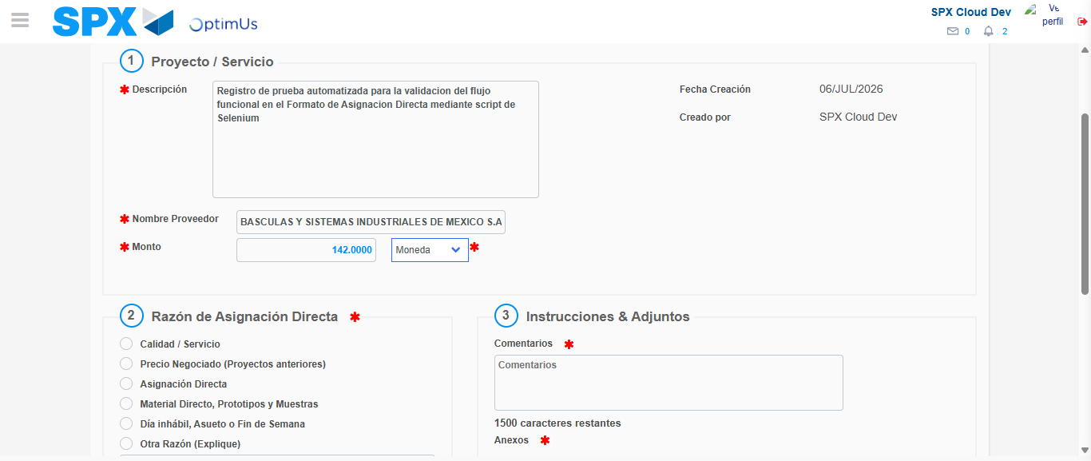Image file-name: QC_Testing-tc002_SPX_Dev5_Crear_Requisicion_Spot_Con_FAD_Tipo_Cobro_CC-1783355510087

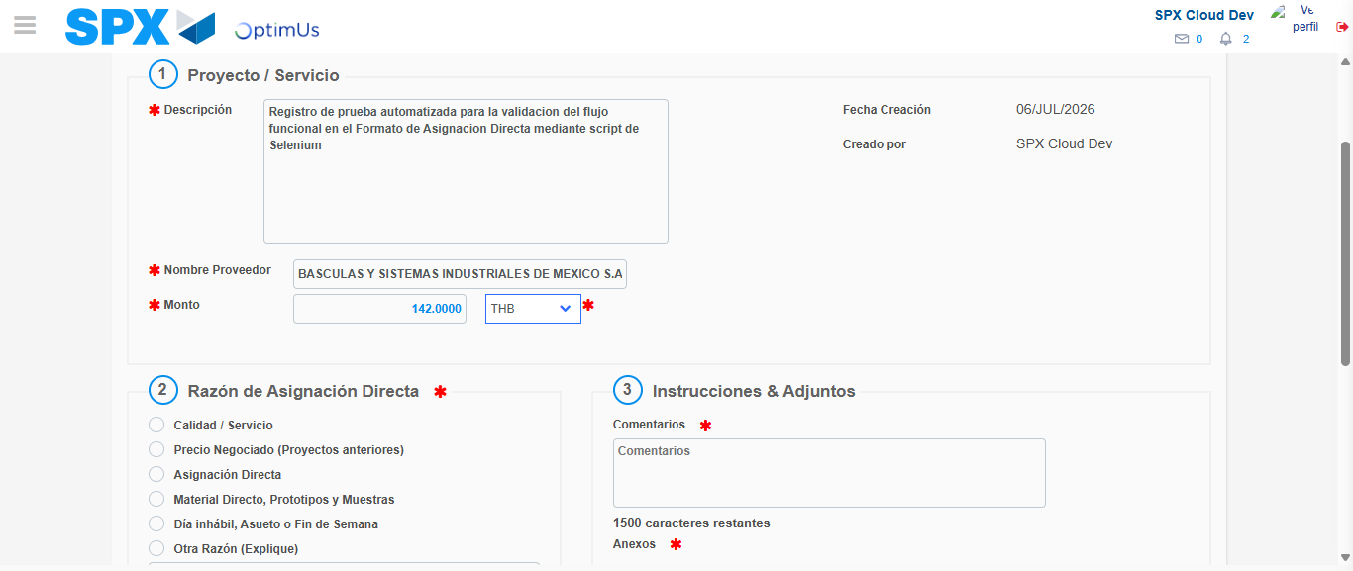Image file-name: QC_Testing-tc002_SPX_Dev5_Crear_Requisicion_Spot_Con_FAD_Tipo_Cobro_CC-1783355510536

Image file-name: QC_Testing-tc002_SPX_Dev5_Crear_Requisicion_Spot_Con_FAD_Tipo_Cobro_CC-1783355510732

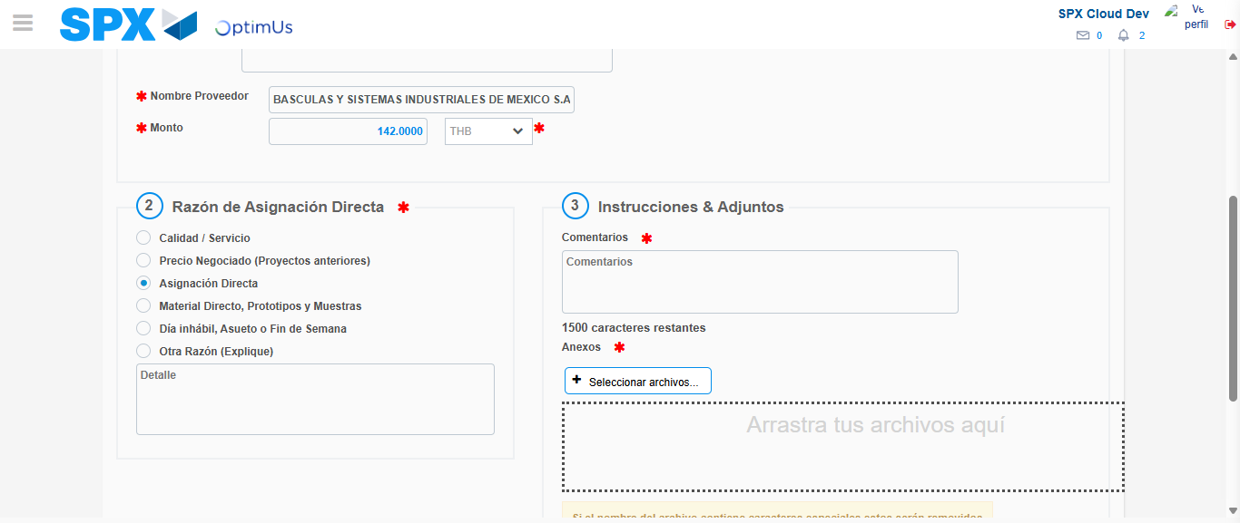Image file-name: QC_Testing-tc002_SPX_Dev5_Crear_Requisicion_Spot_Con_FAD_Tipo_Cobro_CC-1783355511646

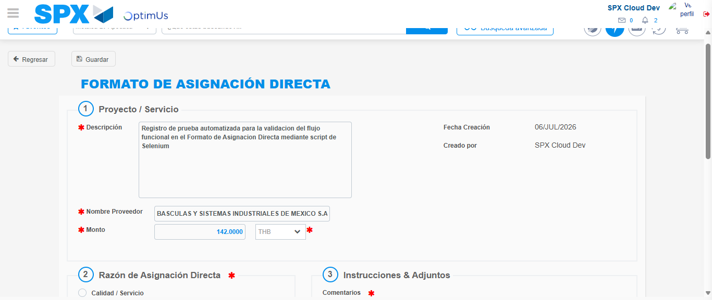Image file-name: QC_Testing-tc002_SPX_Dev5_Crear_Requisicion_Spot_Con_FAD_Tipo_Cobro_CC-1783355523000

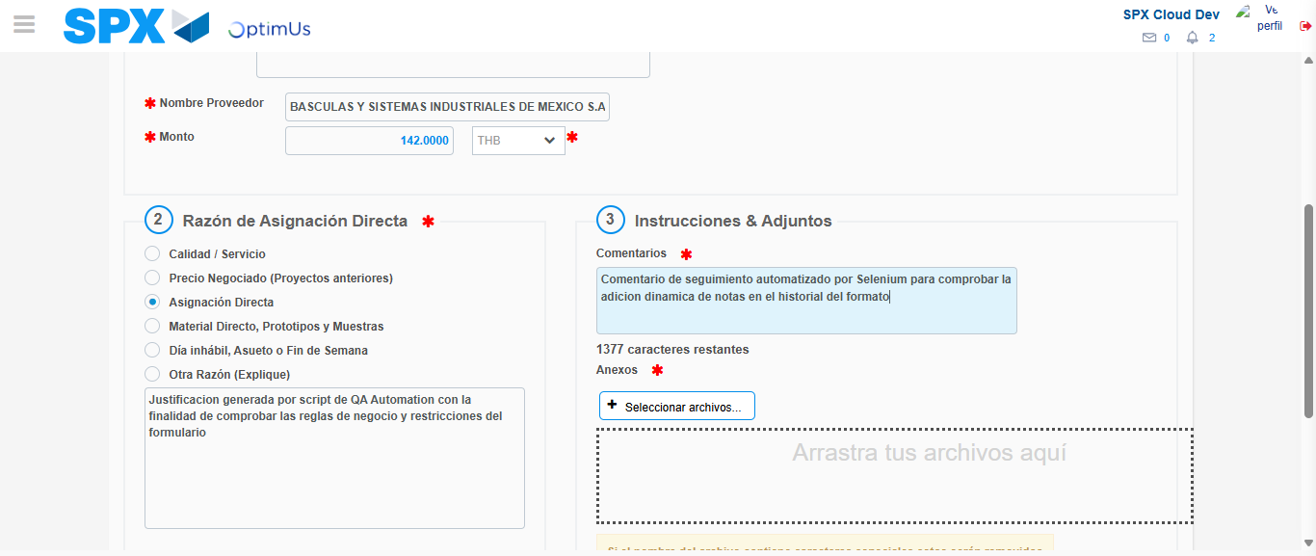Image file-name: QC_Testing-tc002_SPX_Dev5_Crear_Requisicion_Spot_Con_FAD_Tipo_Cobro_CC-1783355523669

Step 4 - Data Capture Spot Buy Requisition: Data captured correctly
Image file-name: QC_Testing-tc002_SPX_Dev5_Crear_Requisicion_Spot_Con_FAD_Tipo_Cobro_CC-1783355497644

Image file-name: QC_Testing-tc002_SPX_Dev5_Crear_Requisicion_Spot_Con_FAD_Tipo_Cobro_CC-1783355497859

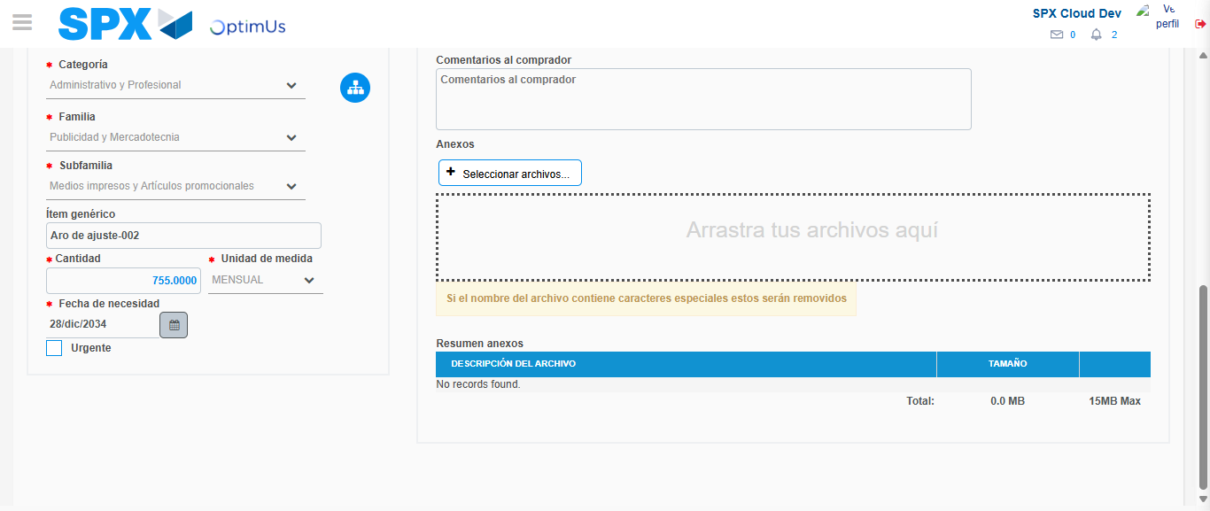Image file-name: QC_Testing-tc002_SPX_Dev5_Crear_Requisicion_Spot_Con_FAD_Tipo_Cobro_CC-1783355534695

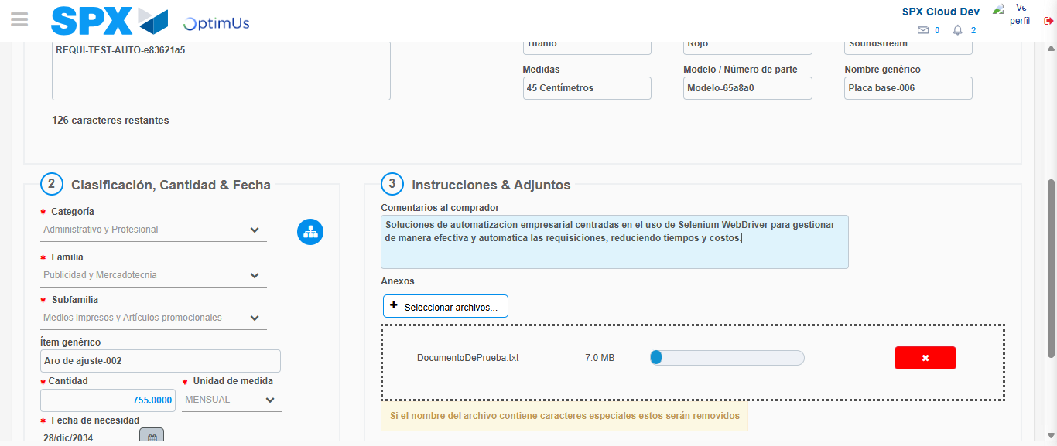Image file-name: QC_Testing-tc002_SPX_Dev5_Crear_Requisicion_Spot_Con_FAD_Tipo_Cobro_CC-1783355535525

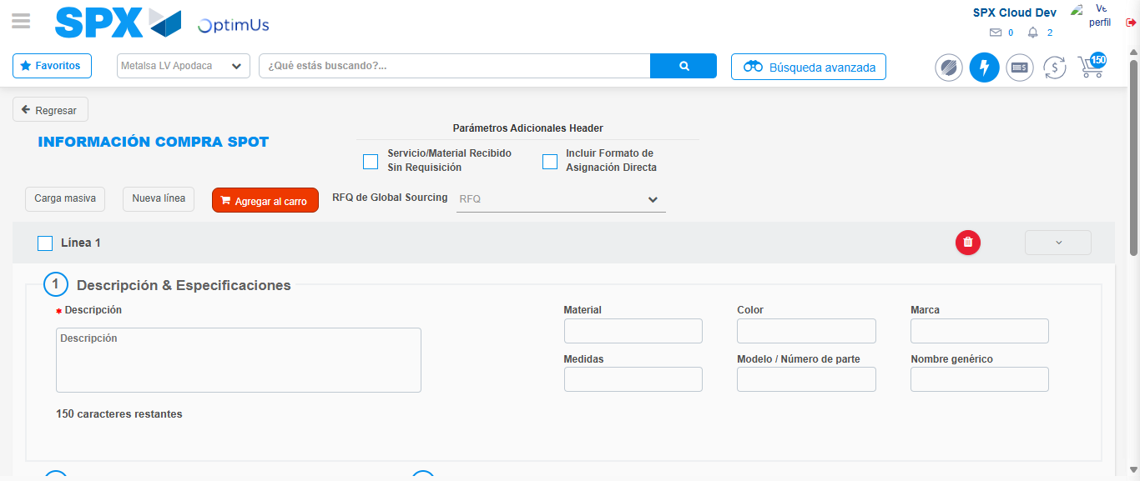Image file-name: QC_Testing-tc002_SPX_Dev5_Crear_Requisicion_Spot_Con_FAD_Tipo_Cobro_CC-1783355541581

Step 8 - Return to Main Page SPX : Return to Main Page SPX
Image file-name: QC_Testing-tc002_SPX_Dev5_Crear_Requisicion_Spot_Con_FAD_Tipo_Cobro_CC-1783355469377

Image file-name: QC_Testing-tc002_SPX_Dev5_Crear_Requisicion_Spot_Con_FAD_Tipo_Cobro_CC-1783355472077

Image file-name: QC_Testing-tc002_SPX_Dev5_Crear_Requisicion_Spot_Con_FAD_Tipo_Cobro_CC-1783355497351

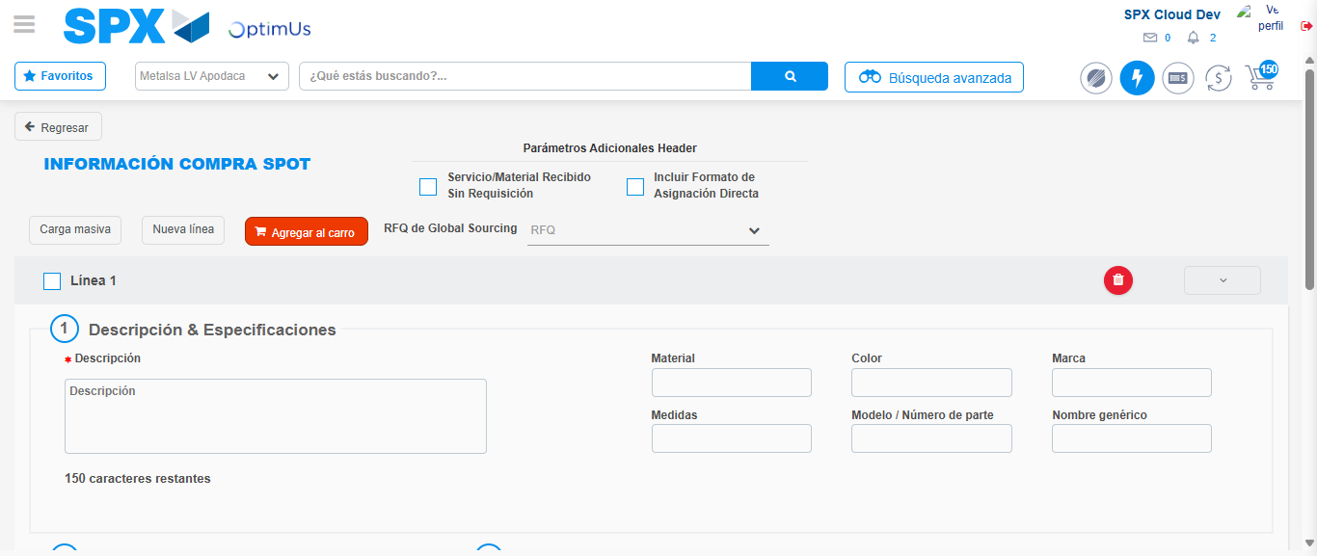Image file-name: QC_Testing-tc002_SPX_Dev5_Crear_Requisicion_Spot_Con_FAD_Tipo_Cobro_CC-1783355543799

Image file-name: QC_Testing-tc002_SPX_Dev5_Crear_Requisicion_Spot_Con_FAD_Tipo_Cobro_CC-1783355543968

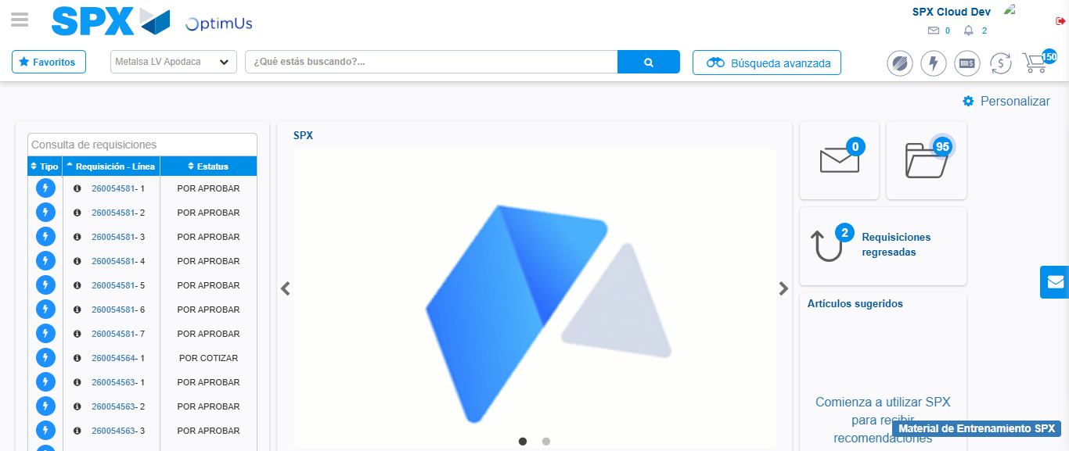Image file-name: QC_Testing-tc002_SPX_Dev5_Crear_Requisicion_Spot_Con_FAD_Tipo_Cobro_CC-1783355565072

Step 9 - Log Out : Log Out SPX
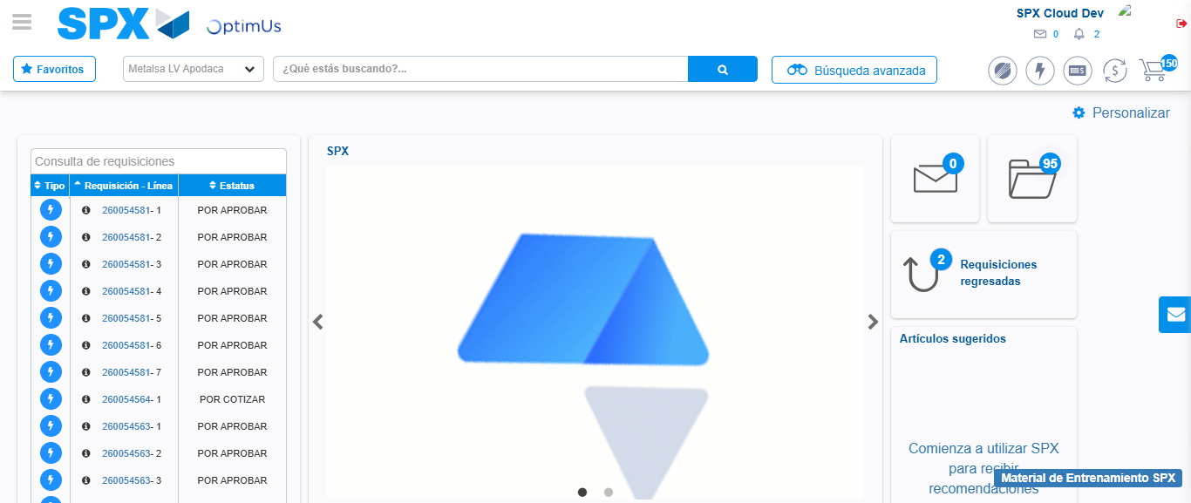Image file-name: QC_Testing-tc002_SPX_Dev5_Crear_Requisicion_Spot_Con_FAD_Tipo_Cobro_CC-1783355565350

